Nama : HANIF FIRDAUS ILLAHI

NIM : L200180021

Tanggal Praktikum : 13 Maret 2018

1.

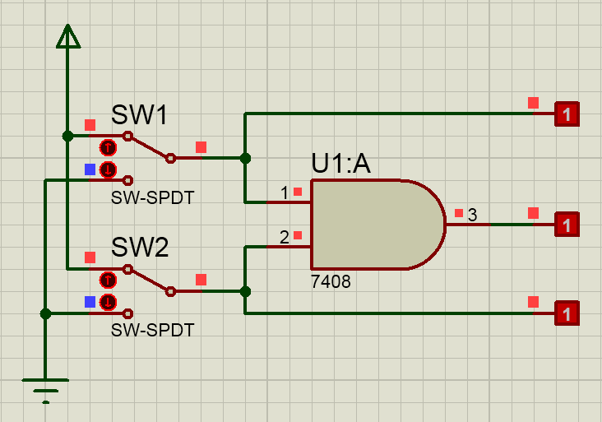

|  |  |  |  |  |
| --- | --- | --- | --- | --- |
| SW 1 | SW 2 | L1 | L2 | L3 |
| 0 | 0 | 0 | 0 | 0 |
| 1 | 0 | 1 | 0 | 0 |
| 0 | 1 | 0 | 1 | 0 |
| 1 | 1 | 1 | 1 | 1 |

L1 

L2 

3 

2.

|  |  |  |  |  |
| --- | --- | --- | --- | --- |
| SW 1 | SW 2 | L1 | L2 | L3 |
| 0 | 0 | 0 | 0 | 0 |
| 1 | 0 | 1 | 0 | 1 |
| 0 | 1 | 0 | 1 | 1 |
| 1 | 1 | 1 | 1 | 1 |

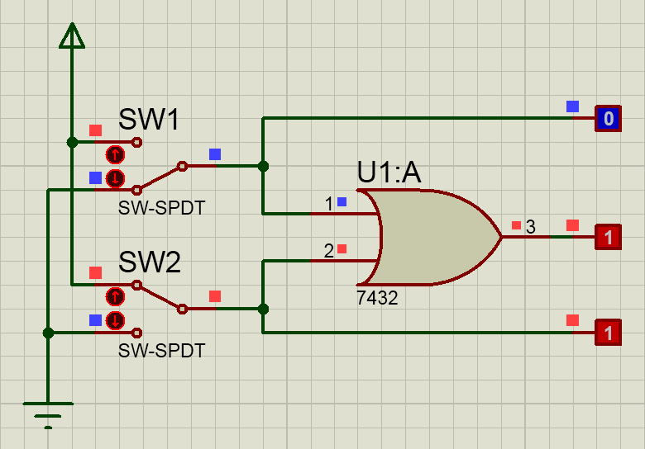

L1



L2



L3



Percobaan 3. NOT

|  |  |  |
| --- | --- | --- |
| SW 1 | L2 | L1 |
| 0 | 0 | 1 |
| 1 | 1 | 0 |

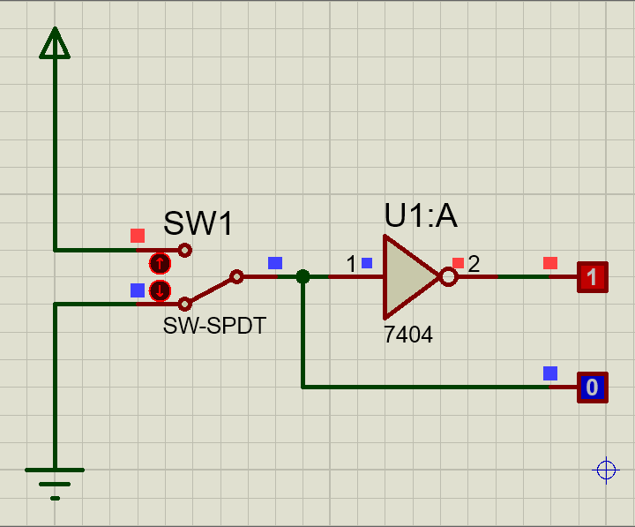

L2



L1



Percobaan 4. NAND

|  |  |  |  |  |
| --- | --- | --- | --- | --- |
| SW 1 | SW 2 | L1 | L2 | L3 |
| 0 | 0 | 0 | 0 | 1 |
| 1 | 0 | 1 | 0 | 1 |
| 0 | 1 | 0 | 1 | 1 |
| 1 | 1 | 1 | 1 | 0 |

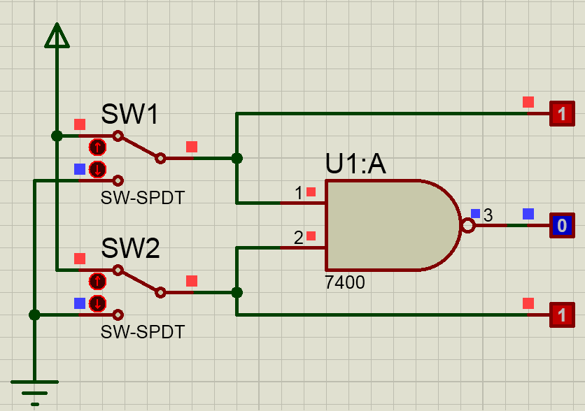

L1



L2



L3



Percobaan 5. NOR

|  |  |  |  |  |
| --- | --- | --- | --- | --- |
| SW 1 | SW 2 | L1 | L2 | L3 |
| 0 | 0 | 0 | 0 | 1 |
| 1 | 0 | 1 | 0 | 0 |
| 0 | 1 | 0 | 1 | 0 |
| 1 | 1 | 1 | 1 | 0 |

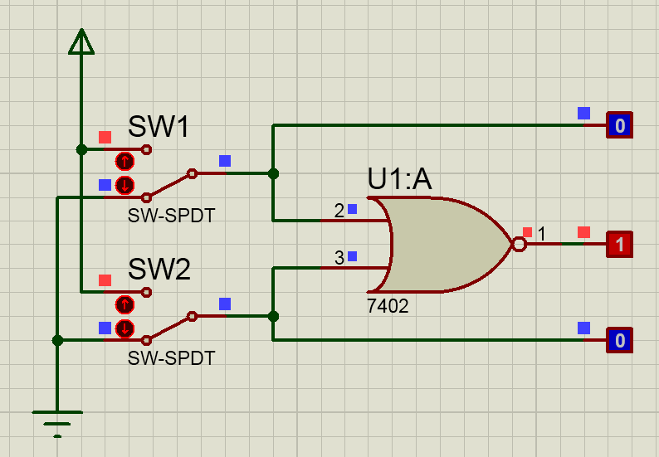

L1



L2



L3



Percobaan 6. XOR

|  |  |  |  |  |
| --- | --- | --- | --- | --- |
| SW 1 | SW 2 | L1 | L2 | L3 |
| 0 | 0 | 0 | 0 | 0 |
| 1 | 0 | 1 | 0 | 1 |
| 0 | 1 | 0 | 1 | 1 |
| 1 | 1 | 1 | 1 | 0 |

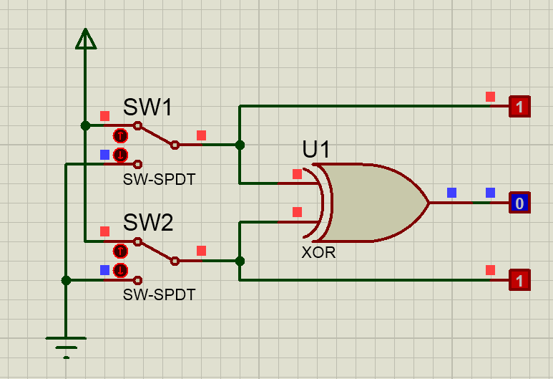

L1



L2



L3



Percobaan 7. XNOR

|  |  |  |  |  |
| --- | --- | --- | --- | --- |
| SW 1 | SW 2 | L1 | L2 | L3 |
| 0 | 0 | 0 | 0 | 1 |
| 1 | 0 | 1 | 0 | 0 |
| 0 | 1 | 0 | 1 | 0 |
| 1 | 1 | 1 | 1 | 1 |

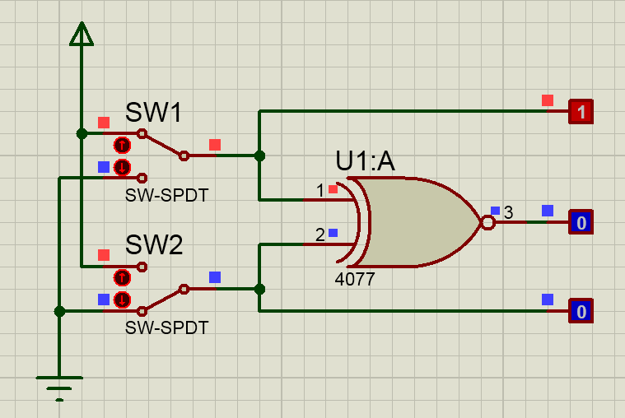

L1



L2



L3

